DmgCtrl, Ltd.

Repo.app Testing Guidelines

1. Install the latest version of Repo.app on your computer.
2. Run Repo.
3. Call Repo within applications or at the Terminal command line by clicking <control> + <space> on your keyboard or clicking the icon in your Dock.
4. Clone the “Repo Testing” repository by calling Repo and typing “clone” in the “Type the name of a repository or command” field that appears. Double-click the “Clone…” bar that appears. 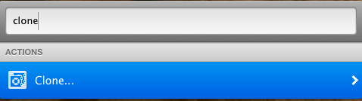
5. Type in the name of the remote repository to clone (or copy-and-paste it): git@github.com:JayNewlin/Repo_Testing.git